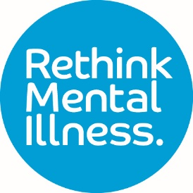

Wixii macluumaad dheeraad ah oo ku saabsan Waaya-aragnimada Ololaha Daryeelka (Experience of Care Campaign) ama sida aad fikradaada uu bixiso!

**Waxaan rabnaa inaan ogaanno waayo-aragnimadaada!**

Marka aad ka qayb-qaadato waayo-aragnimada ololaha daryeelka codkaagu wuxuu ina siin doonaa aragti ku saabsan waayo-aragnimada bulshooyinka Birmingham iyo Solihull marka ay helayaan taageerada caafimaadka maskaxda.

**Miyaad ku isticmaashay Birmingham ama Solihull adeegyada caafimaadka maskaxda?**

Rethink Mental Illness, waa Shirkad dammaanad lagu xaddiday. Ka Diiwaangashan England Lambar 1227970 Lambarka Samofal ee Diiwaangashan 271028. Xafiiska Diiwaangashan 28 Albert Embankment, London, SE1 7GA

Waxaa nidaamiyay Maamulka Dhaqanka Maaliyadda (Lambarka Diiwaangelinta Shirkadda waa 624502). © Rethink Mental Illness

Wuxuu ku caawiyaa ogeysiiska hagaajinta adeegyada iyo mudnaanta.

**Iimayl: Experienceofcarebsol@rethink.org**

**Waayo-aragnimada Daryeelka**

Birmingham & Solihull

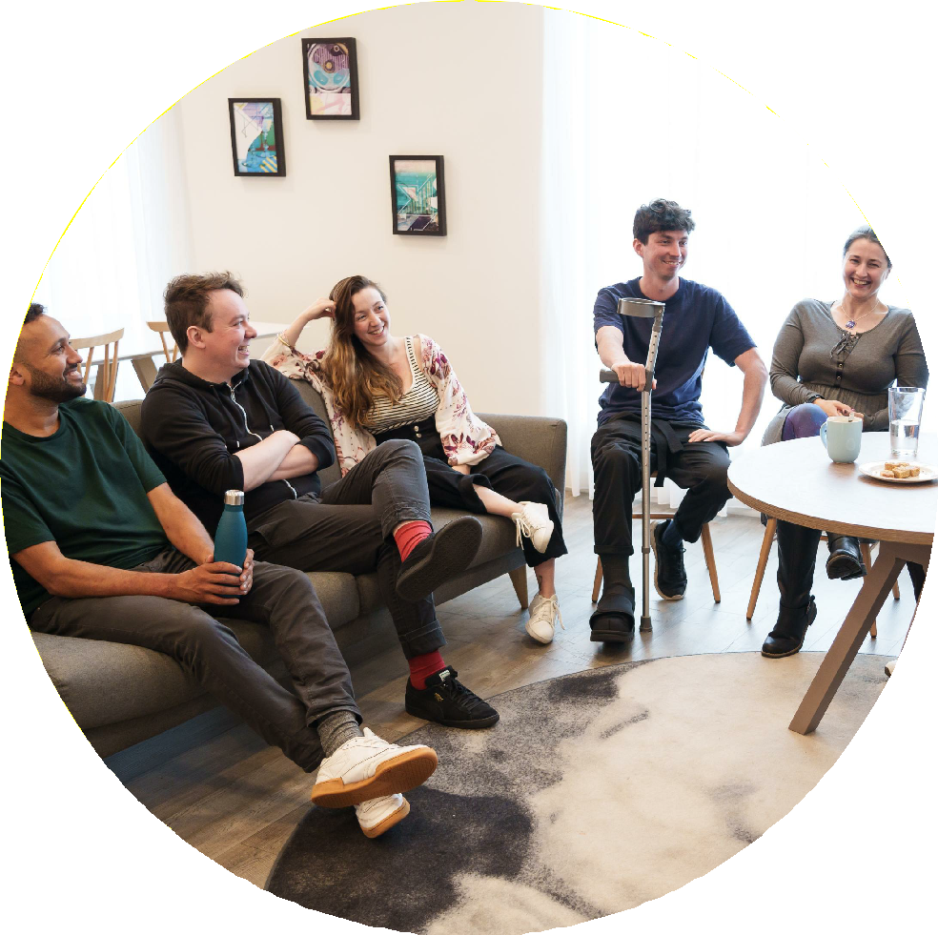

**rethink.org**