Single session workshops online using Zoom are offered free of charge, and often followed after a few weeks with a discussion group.
Finding balance in a Caring Role  Being there for someone with mental health issues can bring out the best in us, but can also make us feel a range of negative emotions. This workshop is for family members, partners and friends to acknowledge and explore the difficulties of a caring role, as well as how to find compassion for ourselves.  Duration: 1.5 hours  Facilitators: Karen Allen (Rethink Carers Service), Jane Brown (Central Recovery Team). | 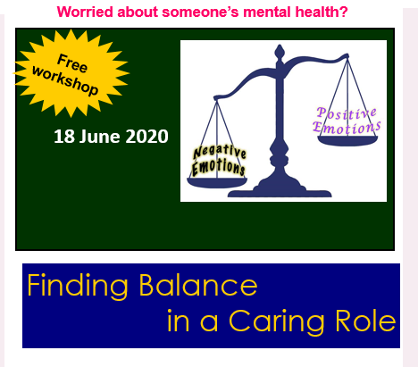
 | 18th June 2020

Communicating with someone experiencing mental health issues
When someone is unwell, it can be difficult to know how to keep calm and avoid triggering distress and conflict for each other but still talk about the things that matter.
Sharing what has worked for us and what hasn’t with others, and practising voicing how we feel can help us to gain confidence and skill in communicating more effectively.

Duration: 1.5 hours with follow up discussion after 2+ weeks  Facilitators: Karen Allen (Rethink Carers Service), Jane Brown (Central Recovery Team). | 14th July 2020

Recovery – what’s it all about?  It can be difficult to know how to help someone to recover from mental illness. We will all have wondered at some time whether we are doing the right thing, and question what guides mental health workers and ‘recovery navigators’ in their work.  Duration: 1.5 hours with follow up discussion after 2 weeks  Facilitators: Karen Allen & Margaret Price (Rethink Carers Service), Suzanne Gerrish (Community Rehab Team) | 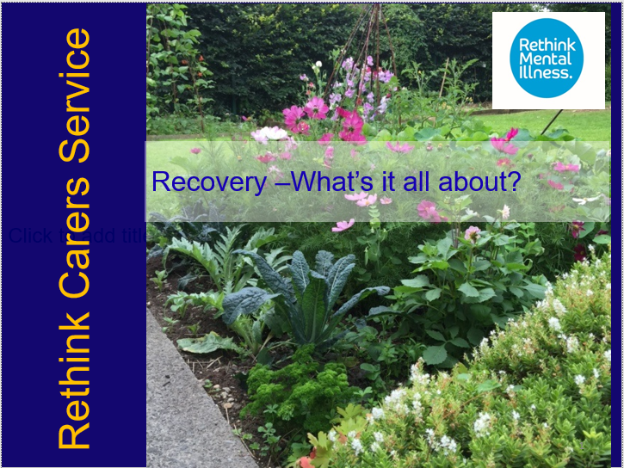
 | 30th Sept 2020
2021

Attitudes and experiences in mental health
A space to explore identity, wellbeing and mental health within Black, Asian and Minority Ethnic communities. Including a focus on self-care, support, and addressing attitudes and inequalities within society and services to improve our wellbeing.

Duration: 1.5 hours
Facilitators: Karen Allen & Margaret Price (Rethink Carers Service), Narinder Chana (BME Community Development worker, Rethink).
early 2021

Triangle of Care  The Triangle of Care sets out how carers, service users and professionals should work together to promote safety and recovery and to sustain the wellbeing of those using mental health services by including and supporting carers.  But how does it work in practice? What can family members learn about this guidance that will help them to be involved in someone’s care?  Duration: 2 hours  Facilitators: Karen Allen & Margaret Price (Rethink Carers Service) | 