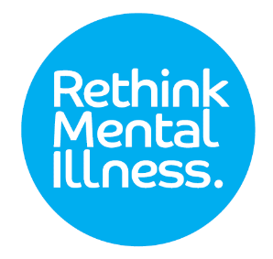

**Have your voice heard!**

**Rethink Mental Illness needs you!**

We are currently looking for **‘Champions’** to volunteer within secure services to support the Recovery and Outcomes Groups.

**What are Recovery and Outcomes Groups?**

* We meet regularly through the year for a whole afternoon, including lunch.
* We bring together service users, staff and commissioners from adult medium and low secure services.
* We have presentations from service users and staff about things that have been happening in the service, regionally and nationally, and about things that are important to them.
* We have lots of interesting discussion on different topics.
* Together we provide lots of views and ideas that influence how services are run.
* All service users are invited.



**Exciting opportunity to develop local champions who can support the Recovery and Outcome Groups!**

**The Recovery and Outcomes champions will:**

* Encourage more service users and staff to get involved in the Recovery and Outcomes Groups.
* Support people who cannot attend the Recovery and Outcomes Groups in person, to feed in their ideas and views.
* Come to the Recovery and Outcomes Group and share what other people at their service have said.
* Feedback to people in their service after the Recovery and Outcomes Group has taken place.
* Develop their skills and help to build their confidence by encouraging people to share their views, doing presentations and leading discussions

**To find out more:**

Talk to a member of staff who can contact Recovery and Outcomes at:

[**recoveryandoutcomes@rethink.org**](mailto:recoveryandoutcomes@rethink.org)

**020 7840 3126**

**Rethink Mental Illness, 89 Albert Embankment London SE1 7TP**