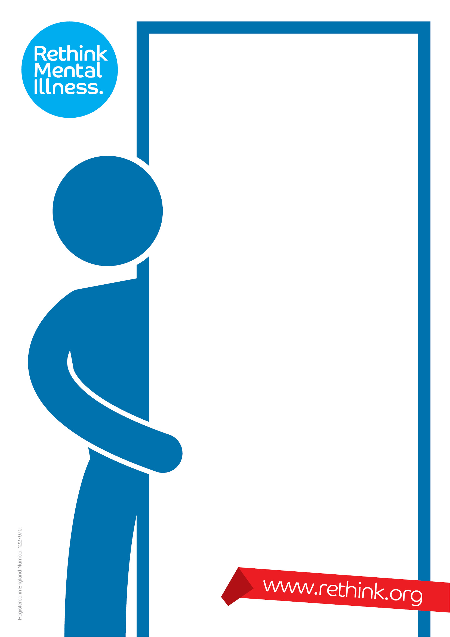

**Caring and coping**

Do you support a relative, friend or neighbour due to

their mental illness? If so then this could be for you

“To engage in such a course was most uplifting and helpful. It is the first course in 14 years of caring that I have been able to do which is specific to mental illness.”

**What do the workshops cover and when are they?**

You can either book onto all of the workshops below, or just pick and choose the one’s which you’re most interested in:

|  |  |
| --- | --- |
| **Workshop Sessions** | |
| What does it mean to be a carer? | Dealing with challenges |
| Understanding mental health and mental illness | The law and the mental health system |
| What does mental illness feel like? | Treatments and therapies |
| The impact of mental illness | Money and benefits |
| The carer’s journey | Looking after yourself |

All workshops are Free and are aimed at anyone who is supporting someone who is over 18 years old

For more information or to book a place please contact us on

01305 262771

**Who Is It For and How Much Does it Cost?**

The course is **Free** and is aimed at anyone who is supporting a family member or friend who is aged over 18 years old

Programme

27th September 2016 What does it mean to be a carer?

18th October 2016 Understanding mental health and

mental illness

15th November 2016 What does mental illness feel like?

13th December 2016 The impact of mental illness

24th January 2017 The carer’s journey

21st February 2017 Looking after yourself

21st March 2017 The law and the mental health system

25th April 2017 Treatments and therapies

23rd May 2017 Money and benefits

20th June 2017 Dealing with challenges

**For further information or to book a place please contact:**

**Mark Champion - 01305 262771**

**mark.champion@rethink.org**