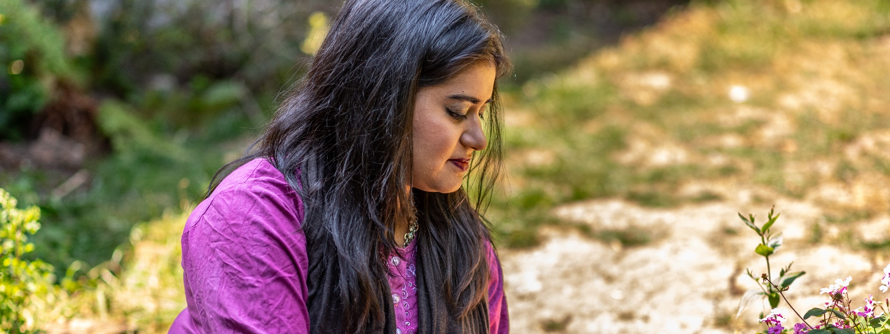
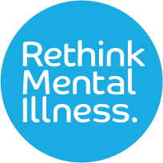

Expert by Experience (EbE)

Diversity monitoring form

Why this data is important to us
Rethink Mental Illness seeks to ensure that our organisation and our services are relevant and accessible to all. We value fresh perspectives and insights gained by involving and welcoming people from diverse backgrounds, cultures, and experiences. In line with our values we aim to be an equal, diverse, and inclusive organisation. We collect diversity monitoring information to help us know the demographics of the Experts by Experience we are reaching so we can be proactive in trying to engage those who we might not be hearing from. This is why we ask about protected characteristics (personal characteristics that are protected by law). This will help us to be as inclusive as possible in our involvement and co-production work.

Data categories
Our diversity monitoring form has been developed with the support of Rethink Mental Illness colleagues and Experts by Experience who have given feedback on our previous forms and offered ideas on how to improve this. It is important to note that not everyone will identify with the categories which have been outlined or want to answer them. We have provided the option to select ‘other’ and to self-describe, or to ‘prefer not to say’. We know that language and terminology can change quite quickly; therefore, through regular review, we will try to ensure it remains relevant and up to date. If you have any feedback around terminology in this form, you can email involvement@rethink.org.

How we will use, store and share the data
We recognise that this data is highly sensitive, and it will be treated with the strictest confidence. The information you provide is purely voluntary and you are able to select ‘prefer not to say’, should you wish to do so. All data will be retained in line with relevant Data Protection legislation, our data related policies and Privacy Policy.

Your data will be held securely and only shared with those who require access to this. This includes our Involvement and Co-production team, HR, Diversity, Equity and Inclusion team, and Evidence and Impact team. When reporting back on Expert by Experience diversity data, this will be anonymised (meaning your name will not be shown). Your data will be deleted after 6 years, in line with our Data Retention and Disposal Policy.

If you have any queries about anything contained in this form, or wish to notify us of any changes to your information, or request your information be deleted please contact involvement@rethink.org
Gender Identity:
☐ Female | ☐ Male |  |  | ☐ Gender Fluid |  |  | ☐ Non-binary
☐ Prefer not to say | ☐ Other, please describe: Click or tap here to enter text.
Is your gender identity the same as the sex you were assigned at birth?
☐ Yes |  | ☐ No |  |  | ☐ Prefer not to say
Age Group:
☐ Under 18 | ☐ 18-24 |  |  | ☐ 25-34 |  | ☐ 35-44
☐ 45-54 | ☐ 55-69 |  |  | ☐ 70+ |  | ☐ Prefer not to say
Ethnicity:
Asian/Asian British
☐ Bangladeshi | ☐ Chinese |  |  | ☐ Indian |  |  | ☐ Pakistani
☐ Any other Asian background, please describe: Click or tap here to enter text.
Black/Black British
☐ African background, please describe:  Click or tap here to enter text. |  |  |  | ☐ Caribbean
☐ Any other Black/ Black British background, please describe: Click or tap here to enter text.
Mixed/Multiple Ethnic Groups
☐ White and Black  Caribbean |  | ☐ White and Black  African |  |  | ☐ White and Asian
☐ Any other Mixed background, please describe: Click or tap here to enter text.
White
☐ Irish |  | ☐ Gypsy or Irish Traveller |  |  | ☐ Roma
☐ English, Welsh, Scottish, Northern Irish or British
☐ Any other White background, please describe: Click or tap here to enter text.
Any other Ethnic group
☐ Arab |  |  | ☐ Prefer not to say
☐ Other, please describe: Click or tap here to enter text.

Religion or Belief:
☐ Agnostic | ☐ Atheist |  |  | ☐ Buddhist |  |  |  | ☐ Christian  (all denominations)
☐ Hindu | ☐ Jewish |  |  | ☐ Muslim |  |  |  | ☐ Sikh
☐ Spiritual |  | ☐ No religion/belief |  |  |  | ☐ Prefer not to say
☐ Any other religion/belief, please describe: Click or tap here to enter text.
Sexual Orientation:
☐ A-sexual | ☐ Bi-sexual |  |  | ☐ Gay |  |  |  |  | ☐ Heterosexual
☐ Lesbian | ☐ Pansexual |  |  | ☐ Queer |  |  |  |  | ☐ Questioning
☐ Prefer not to say | ☐ Other sexual orientation, please describe:  Click or tap here to enter text.
Marriage and Civil Partnership Status:
☐ Single | ☐ Married |  |  | ☐ Divorced |  |  |  |  | ☐ Widowed
☐ Separated | ☐ Co-habiting |  |  | ☐ Civil Partnership |  |  |  |  | ☐ Dissolved Civil  Partnership
☐ Surviving partner from a civil partnership |  |  |  | ☐ Prefer not to say
☐ Other, please describe: Click or tap here to enter text.
Disability, health conditions, and neurodiversity
Do you consider yourself to have a disability or long-term health condition?
(A disability is when we live with a physical or mental impairment that has a substantial and long-term impact on our
ability to carry out day to day activities. A long term health condition is an illness that cannot be cured, but can be
controlled by medications &/ therapies).
☐ Yes |  |  | ☐ No |  |  |  | ☐ Prefer not to say
Which of these best describe your condition(s)? Please tick as many as apply.
☐ Hearing Impairment |  |  | ☐ Learning Difference |  | ☐ Long term medical condition
☐ Long term mental ill health |  |  | ☐ Physical Impairment |  | ☐ Speech Impairment
☐ Visual Impairment |  |  | ☐ None |  | ☐ Prefer not to say
☐ Other, please describe: Click or tap here to enter text.
Do you consider yourself to be neurodivergent? (The term neurodivergent refers to a range of neurocognitive differences that an individual possesses, and this can affect how they think, experience and interact with the world around them. We may be born neurodivergent or develop a neurodivergency through our experiences).
☐ Yes |  |  | ☐ No |  |  |  | ☐ Prefer not to say
Which of these best describe your neurodivergency(ies)? Please tick as many as apply.
☐ ADHD | ☐ Autism |  |  | ☐ Brain Injury |  |  |  |  | ☐ Dyslexia
☐ Dyspraxia | ☐ Dysgraphia |  |  | ☐ Epilepsy |  |  |  |  | ☐ Mental Health (i.e. bi-polar, schizophrenia)
☐ Trauma |  |  | ☐ Tourettes |  |  |  | ☐ Prefer not to say
☐ Other, please describe: Click or tap here to enter text.
Mental Health – Have you ever needed support for a mental health concern or mental illness?
i.e. therapy, counselling, medication or hospital treatment?
☐ Yes |  |  | ☐ No |  |  |  | ☐ Prefer not to say
Do you have any parental responsibility for a child/children under the age of 18?
☐ Yes |  |  | ☐ No |  |  |  | ☐ Prefer not to say
Are you pregnant, or have you been pregnant in the past 12 months?
☐ Yes |  |  | ☐ No |  |  |  | ☐ Prefer not to say
Caring Responsibilities – Do you have caring responsibility for a family member, partner or friend who needs
help because of their illness, frailty, disability, a mental health need or addiction?
☐ Yes |  |  | ☐ No |  |  |  | ☐ Prefer not to say
Are you a young carer? - A young carer is someone under the age of 18 who looks after a family member or
friend who has a physical or mental health condition, or misuses drugs or alcohol.
☐ Yes |  |  | ☐ No |  |  |  | ☐ Prefer not to say
Have you used carers’ services?
☐ Yes |  |  | ☐ No |  |  |  | ☐ Prefer not to say

Rethink Mental Illness, a company limited by guarantee. Registered in England Number 1227970. Registered Charity Number 271028. Registered Office 28 Albert Embankment, London, SE1 7GR. Authorised and regulated by the Financial Conduct Authority (Firm Registration Number 624502). © Rethink Mental Illness 2023.
Rethink Mental Illness, a company limited by guarantee. Registered in England Number 1227970. Registered Charity Number 271028. Registered Office 28 Albert Embankment, London, SE1 7GR. Authorised and regulated by the Financial Conduct Authority (Firm Registration Number 624502). © Rethink Mental Illness 2023.

